

1. Open Matlab.
2. In the command window, write “dungtrack” and press enter. The program will now start running automatically.
3. Press “New Project” in the window that appears. Choose the movie file from which you want to track.

Sometimes the program cannot open the movie file. Make sure the movie is not too big. In other cases it might not be able to read the format of the movie. Try to change it to .mp4. To do this open Quicktime 🡪 “File” 🡪 “Export” 🡪 “Movie to MPEG-4” 🡪”Save”.

1. 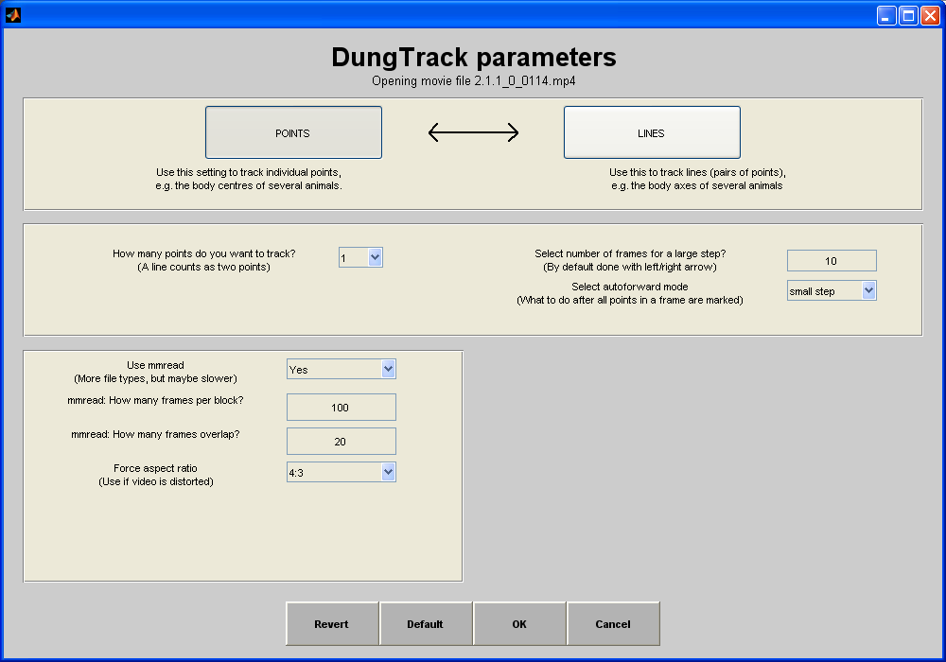A window with adjustable parameters will pop up. Here, you can change the parameters to fit your specific tracking preference.
2. Choose “POINTS” if you are only interested in tracking the trail. Choose “LINES” if you want to include the angle between two or more points (e.g. if you want to look at the angle of a beetles head at a certain point).
3. Choose how many points you want to track (for a regular tracking it is one point).
4. Choose your step size. This tells the program how many frames it should be between each tracked point. A step size of one will make the program track one point in each frame. A step size of ten will make the program track one point every tenth frame.
5. Directly underneath the step size option you can choose between small step, large step (or nothing).
   * A **large step** will make the program jump directly forward to the next tracking point.
   * A **small step** will let you go through every frame independent of step size. For instance, if you choose a step size of 10, the program will have you click through all ten frames until the next tracking point, even though no points are being tracked. Therefore always choose the large step for step sizes greater than one.
   * Choosing **nothing** will make the program not skip to the next frame automatically, but you will have to do in manually.
6. When you are happy with the parameters continue by pressing “ok”. The program will now open.
7. In the tool box that appears in the upper right corner, the step size is displayed. You can at any time change the step size by clicking in the box.

You can go directly to a specific frame or time by tapping the window displaying the frame number/time in the tool box at the top right corner, and typing the preferred frame number/minute in the box that appears.

1. 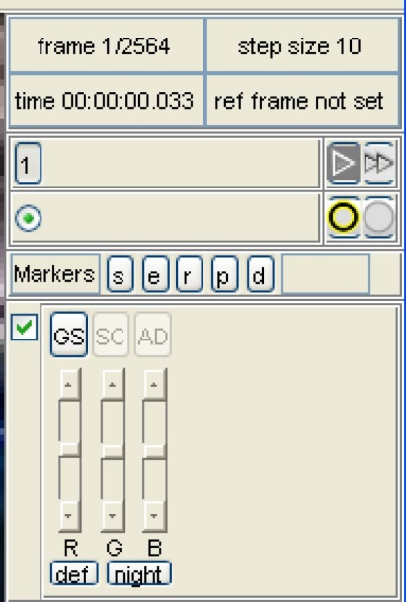The represents a large step. The represents a small step. You can at any time change from large step to small step, or vice versa, by clicking on your icon of choice.
2. Directly underneath are two circular icons. The left circle provides a grey shadow around your marker so you can more easily see it. The right circle will show you the previous position of the current point in your track.
3. If you want to take note of a specific event during your track (e.g. the beetle starts to dance), you can click on one of the many markers provided. If you for instance click “s” at the frame where the dance is initiated, this information can later be extracted in Matlab, and it can be seen at what stage during the track the beetle initiated a dance.
4. Finally the image manipulation panel is shown. With this panel you can adjust the levels of red, green and blue in the file.

In “View” you can choose to display a mini plot window. This will show you everything you are tracking. You can also choose to display or hide any of the previous mentioned panels.

1. Start tracking by left clicking.
2. When you have finished your track, save it as you would a document. Choose “File” 🡪 “Save As”. Your file will be saved as a .res file.

**Calibration**

**If you want your tracked data to be shown according to scale (e.g. to get an overview on exactly how far a beetle has been rolling), you need to calibrate for your tracking. Usually there is a calibration movie made for the data you have tracked. The calibration movie is a movie of a checkerboard pattern shown for the camera at different angles.**

1. Open the calibration movie in Quicktime. You will need to choose a minimum of six different placements of the checkerboard in relation to the camera lens. Note down of the frame number for each position (this will make it easier in the next step). The placements of the checkerboard plate that are important to include are:
2. When the plate is placed flat on the ground.
3. When the plate is positioned very close to the camera lens.
4. When the plate is positioned at each of the four sides within the camera view.
5. Open the same calibration movie in Dungtrack. Go directly to the frame number of the first checkerboard position you had chosen in the previous step. Press ctrl and j. This will turn your frame into a .jpg file that will automatically be saved in the same folder as the movie is in. Do this for all your checkerboard positions. Make sure you save them under the same name (but differently numbered of course). For instance: picture_1.jpg, picture_2.jpg, picture_3.jpg etc.

Remember the number of the image in which the calibration plate is placed flat on the ground (a.). This will be useful further on.

1. Open Matlab.
2. In the column on the far left called “Current Folder” open the folder in which your .jpg files are in.
3. In the command window type “calib_gui”.

In order for the calibration program to run, dungtrack has to have been opened. So if you want to calibrate, you need to open dungtrack (and then you can close it), or the program will not run.

1. In the toolbox that appears, choose “Standard”. A second toolbox will appear.

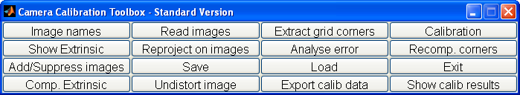

1. Choose “Image Names”. The program will list the names of all the files in that folder.
2. The program will ask you for the “Basename camera calibration images”. Type the name of your .jpg calibration images, without the number or suffix. In our case it will be “picture_”. Press enter.
3. Image format here is .jpg, i.e. “j”. Press enter.
4. All of your calibration images will appear.
5. Next, choose “Extract grid corners”. Press enter to choose all images. The next step that appears allows you to choose the window size for corner finding (“wintx” and “winty”). The smaller the number for these, the better your precision will be. If the images are of poor quality anything under 3 will work fine. Choose manually or press enter.
6. Press enter again to choose the automatic square counting mechanism.
7. Your calibration images will appear in order. Click on the four corners of your checkerboard plate. A tip is to click on the corners of the second row of squares, as the corners of the first, outermost row sometimes can be difficult to see in the image.
8. Always start clicking in the same corner for every image. The program will ask you for the size of each square on the board (it is usually 30 or 40mm). Type that in and press enter. Press enter again to move on to the next image.

Sometimes the program cannot read the number of squares in the image, and it will ask you for them. You will then have to type it in manually.

1. When you are done, choose “Calibration”. The program will calibrate the images.
2. The pixel error should be under 0.5 for optimal result.
3. Choose “Comp. Extrinsic”. Write the name of the image in which the calibration plate is placed on the ground (a.). Leave out the suffix (.jpg). Follow the same procedure as for the previous calibration steps.
4. Click “Save”. This will save everything. To get a calibration file with only the essentials needed for a calibration, type in the command window:

*save(‘whatever-you-want-to-call-it.calib', 'Tc_ext', 'Rc_ext', 'fc', 'cc', 'alpha_c', 'kc');*

This code can also be found in the .m file “dungtrack_calibrate”, which can be found in the dungtrack folder, under the subfolder “calib”.

1. Open dungtrack again.
2. Choose “Open Project” and choose the .res file of the track you want to calibrate for. Dungtrack will also ask for the movie from which you saved the .res file.
3. Choose “Calibration” 🡪 “Attach calibration file”. Attach your calibration file.
4. Choose “Analysis” 🡪 “Plot calibrated path”.
5. Your track will now be shown in relation to scale.
6. Congratulations, you are done!